Home Assignment for Computer Networks

(EDA387)

1 Value discovery in complete graphs

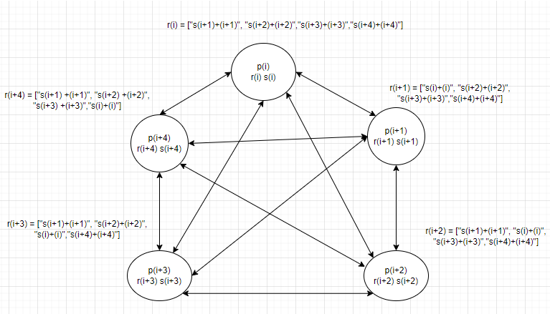

Let us consider the above diagram for a solution to the problem.

In the diagram P (i), P (i+1)… etc are processors, with register r (i) and s (i), for solving the program let us consider the following assumptions:-

1. (i) is the global identifier of the processor and is unique for each processor.
2. The size of the register r(i) is variable and can store the s(i) values in an string array.

Solution:-

Each processors P (i) reads the value of s (i) and global identifier of its each neighboring processes and stores concatenated value (s (i) + i) in its own array r(i) as a string

For example, as shown in the diagram, the

P(i+1),r(i+1) = [“S(i)+(i)”,”S(i+2)+(i+2)”,”S(i+3)+(i+3)”,”S(i+4)+(i+4)”].

Now for P(i), to obtain the value of its own S(i), P(i) can traverse the r(i+1) register of its neighbor P(i+1), and check each element of the string array using the condition such as :-

K = strstr(r(i+1)[p],(i))

if(p!=NULL)

1. r(i+1)[p] -> It is the element of the array in the register r(i+1), at the pth position.
2. (i)-> It is the unique global identifier of the processor P(i).
3. strstr() -> It is a function in C for checking a substring is present in a string. It returns the first position of the substring if the substring has been found, else it returns NULL. Similarly, on using different languages other such as Java, functions such a contains () can also be used to achieve a similar result.
4. We are storing the address in K as we will need it to extract the value of S(i)

In the event the above condition is true, we can now extract the S(i) value of processor P(i), as from the strstr function. We know the first position of the (i) in the string, we have to extract the characters prior to the character (i), for obtaining the value of S(i). For this we can use a function such as strncpy, in the following manner.

strncpy(valueofSi,r(i+1)[p],lengthofS(i))

1. valueofSi -> It is the strings in which the value of S(i) will be stored. If we want the value in integer we can convert using functions for example such as atoi(valueofSi).
2. strncpy() -> It is a function to extract the substring from a given string in C. On using other languages other functions such as substring() in Java to achieve a similar result.
3. lengthofS(i) -> As strncpy() needs to know the length of the string to be extracted, hence we have to count the length of S(i), there are many ways to achieve this value, for example as we know the position of (i) in the string we can count the length from the position of (i) and subtract the same from the total length of r(i+1)[p]. This is only for the program in C, using other languages the process can be made simple by using the functions in Java.

Proof:

For example consider 3 processes as p1, p2 & p3.

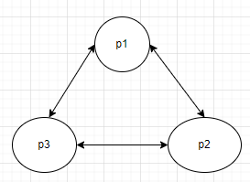

Registers in p1 are s1 & r1

Similarly,

Registers in p2 are s2 & r2

&

Registers in p3 are s3 & r3

As per graph above r1 has connections with two neighboring process so values stored in r1, as follows.

r1 = [“s2+2”,”s3+3”]

Similarly, other 2 processors values of r2 & r3 are as follows.

r2 = [“s1+1”,”s3+3”] & r3 = [“s1+1”,”s2+2”]

If processor p2 wants to know its s2 value, It will reach to any of its neighbor process. Let us assume it has reached to process p1. So p2 will traverse through string array r1 to find its s2 value as follows.

Length of r1 is two, so we need to make two comparisons to find

strstr(r1[1],2) & strstr(r1[2],2)

Here, assume r1[1] = “pass2” so strstr() function checks of global identifier of p2 (assume as 2) in r1[1] and returns position of global identifier. In this case strstr() returns 4.

As strstr has returned some value by that we can conclude that r1[1] is combination of s2 & global identifier of p2. Using some user defined logic we can get s2 value from r1[1].